SQL Assignment – 5
Ques1: Write a querry that will give you all orders for more than Rs. 1000?
Answer:
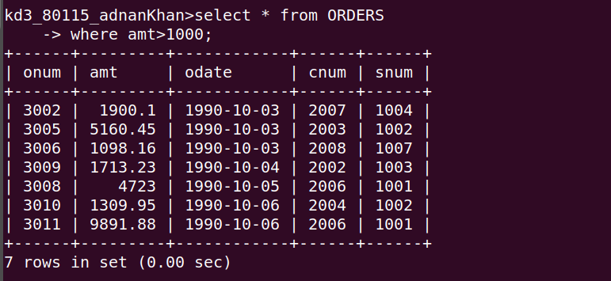

Ques2: Write a query that will give you the name and cities of all salepeople in london with a commision above .10?
Answer:
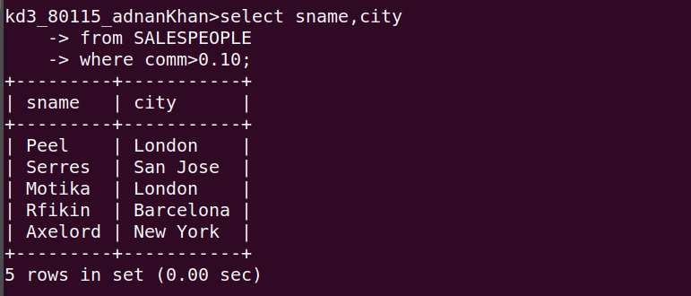

Ques3: Write a query on the customers table whose output will exclude all customers with a rating <=100,unless they are located in Rome?
Answer:
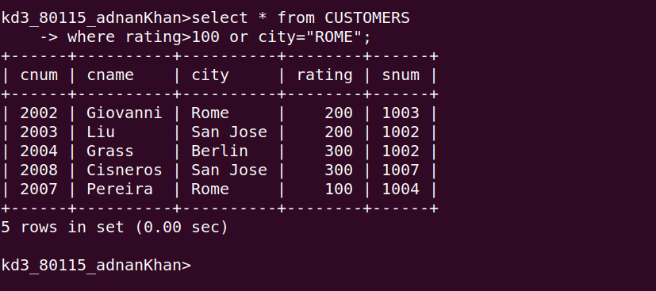

Ques4: What will be the output from the following querry ?
Select * from ORDERS
where (amt<1000 OR
NOT (odate =’1990-10-03’ AND cnum>2003));
Answer:
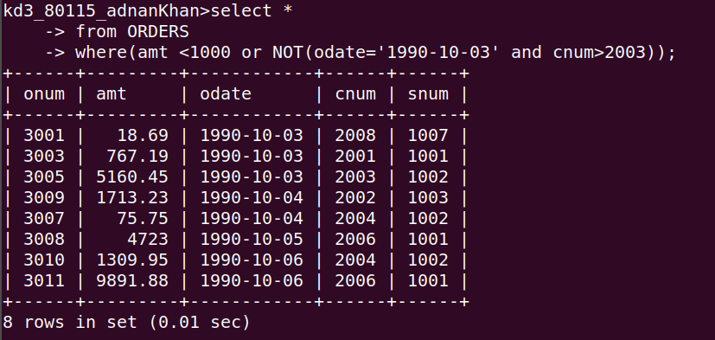

Ques5: What will be the output of the following query?
Select * from orders
where NOT((odate = ‘1990-10-03’ OR snum >1006 ) AND amt >= 1500);
Answer:
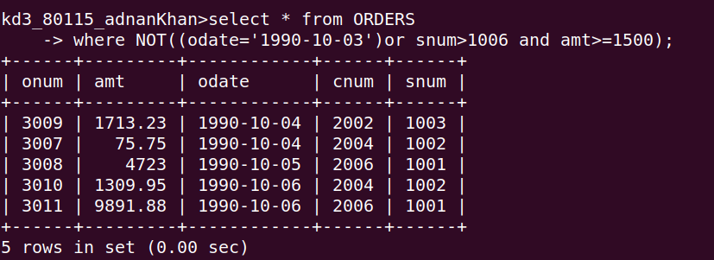

Ques6: What is a simpler way to write this query?
Select snum,sname,city ,comm from salespeople
where(comm>.12 or comm<.14)
Answer:
